实验报告（Lab 3）
姓名：曾泇睷 学号：1820221053
实验：inter-VLAN Routing
Lab 3-1 VLANIF Configuration
Requirements
Requirements The network topology is shown in Figure 3-1. This network has been implemented in Lab-2-4. The computers of Department A are in VLAN 10, and the computers of Department B in VLAN 30. A trunk is configured between the switches to span VLAN cross-switch. Now, it is required to communicate between VLAN 10 and 30 so that departments can share resources. Please configure VLANIF on switches to implement Inter-VLAN Communication.
Step 1: Load and modify the topology.
Step 2: Start devices.
Step 3: Check and finish VLAN Configurations.
Step 4: Configure VLANIF on switch LSW1.
Step 5: Verify the configurations and analyze the traffic on the trunk link.
Answer the following questions:
Q3-1.1. Paste the screenshot of the created topology.
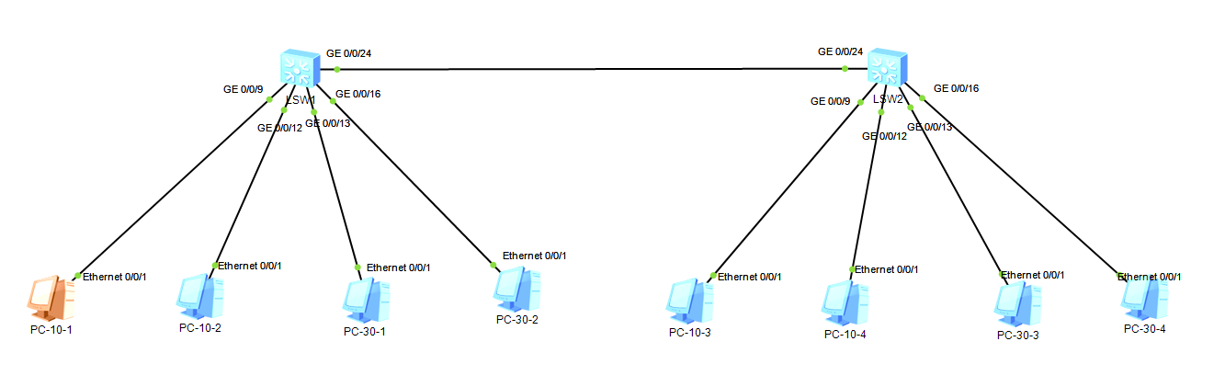

Q3-1.2. Paste the screenshot of the IP routing table on the switch LSW1.
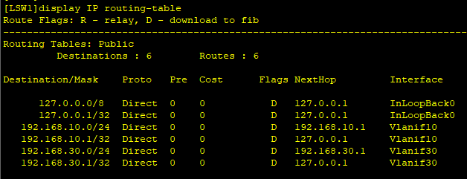

Q3-1.3. Can PC-10-1 and PC-10-3 ping each other? Please paste the screenshot of the ping result.
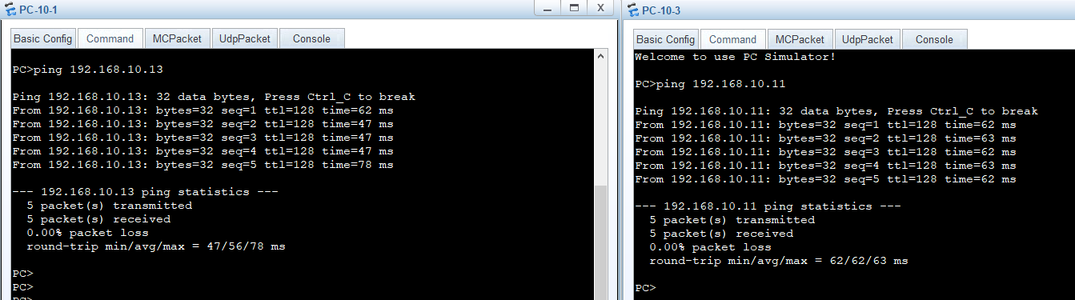

Q3-1.4. Can PC-30-1 and PC-30-3 ping each other? Please paste the screenshot of the ping result.
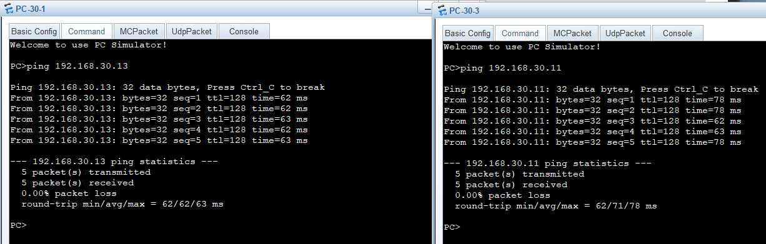

Q3-1.5. Can PC-10-1 and PC-30-3 ping each other? Please paste the screenshot of the ping result.
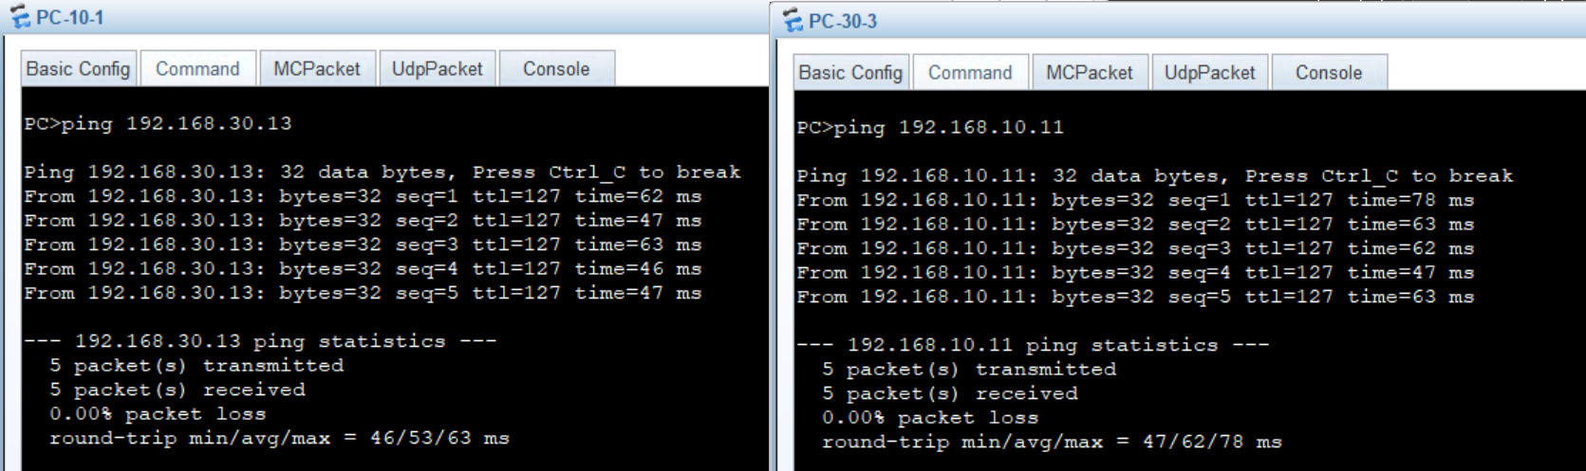

Q3-1.6. Please paste the screenshot of the result of command “tracert 192.168.30.13” issued from PC-10-1.
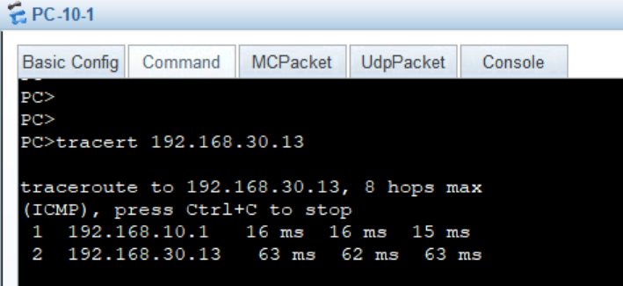

Q3-1.7. Analyze the captured ping traffics between the PC-10-1 and PC-10-3. What are the tagged VLAN IDs of the Ethernet frames leaving and entering the port? Please paste the screenshot of the all field information of the captured Ethernet frame.
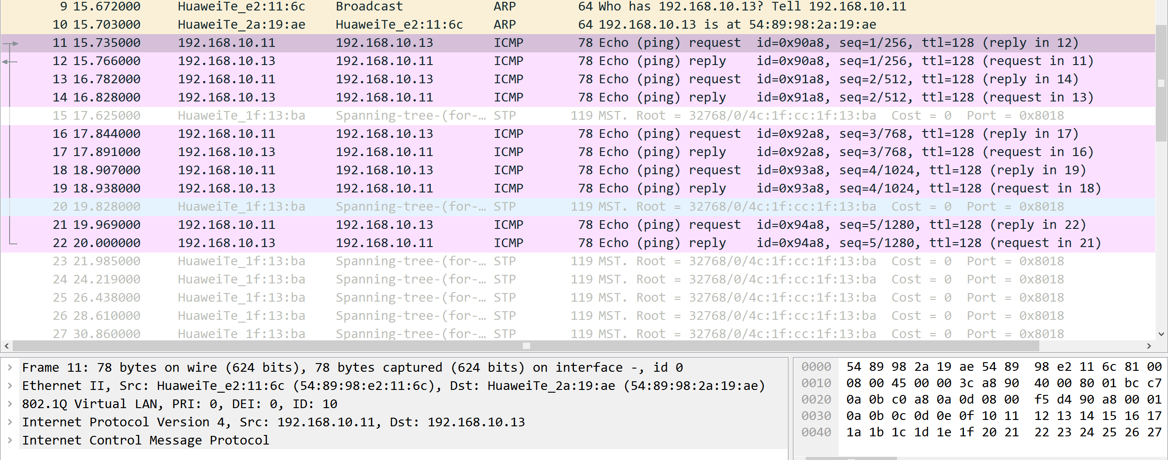
Q3-1.8. Analyze the captured ping traffics between the PC-10-1 and PC-30-3. What are the tagged VLAN IDs of the Ethernet frames leaving and entering the port? Please paste the screenshot of the all field information of the captured Ethernet frames.
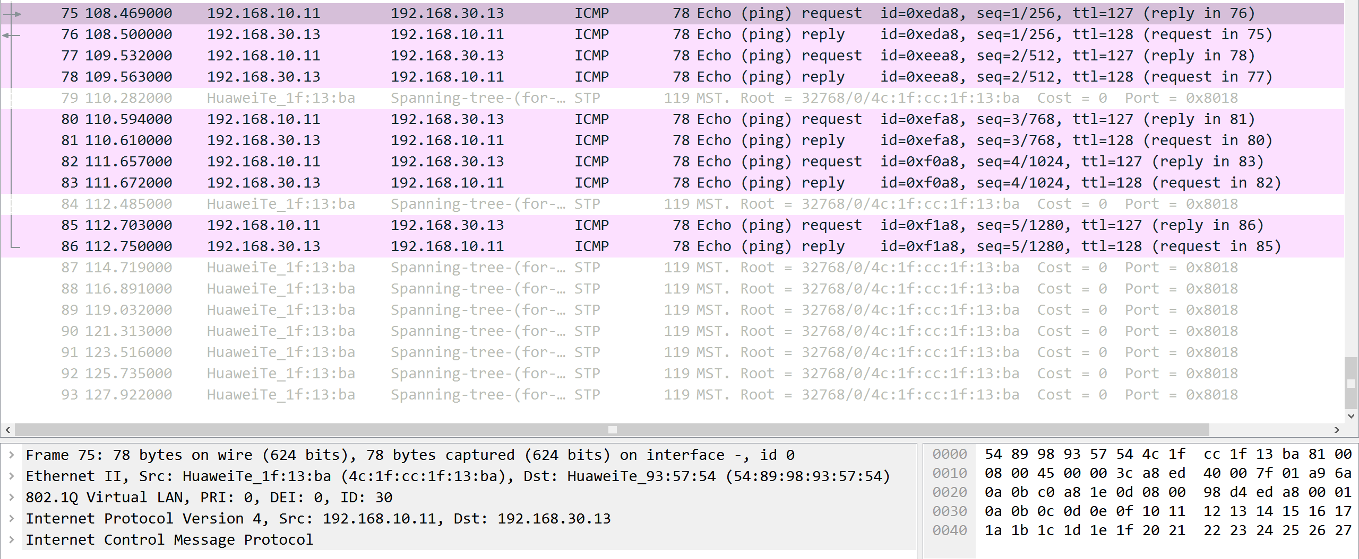

Lab 3-2 One-armed Router Configuration
Requirements
The network topology is shown in Figure 3-1. The computers of Department A and B are connected to the campus network through two S5700 access layer switches LSW1 and LSW2. The access layer switches are connected to a AR2220 router RTA through a S5700 aggregation layer switch LSW3, allowing users to access the campus network and external Internet. The Gigabit ports GE /0/0/9 to GE 0/0/12 on the switches LSW1 and LSW2 belong to VLAN 10 and ports GE 0/0/13 to GE 0/0/16 belong to VLAN 30. The computers of Department A are in VLAN 10, and the computers of Department B in VLAN 30. It is now decided to use a one-armed router and Dot1q termination sub interfaces to implement the communication between VLANs. Please complete the system configurations..
Step 1: Create the topology, cable a network.
Step 2: Assign the IPv4 address and subnet mask for PCs.
Step 3: Start devices.
Step 4: Configure port-based VLANs on switches and trunks between switches.
Step 5: Verify the configurations.
Step 6: Configure the Dot1q termination sub-interface on the router to implement a one-armed router.
Step 7: Verify the configurations and analyze the traffic.
Answer the following questions:
Q3-2.1. Paste the screenshot of the created topology.
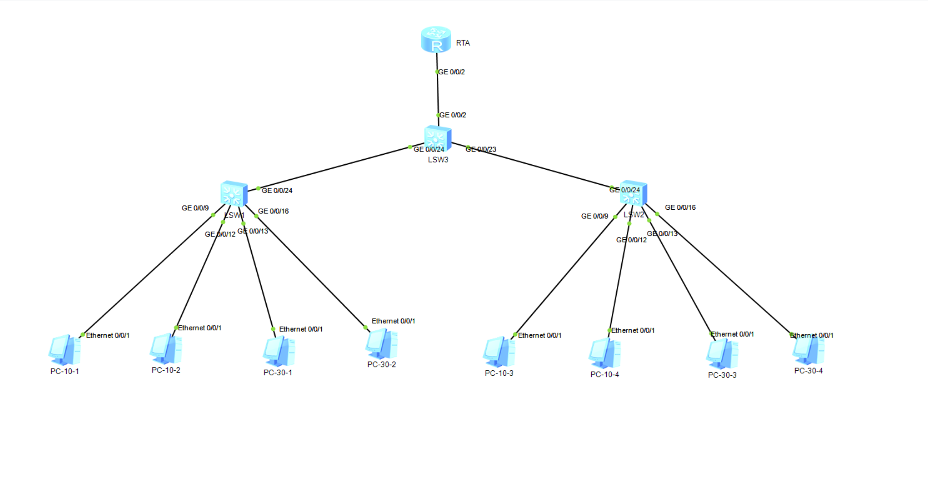
Q3-2.2. Paste the screenshot of the IP routing table on the router RTA.
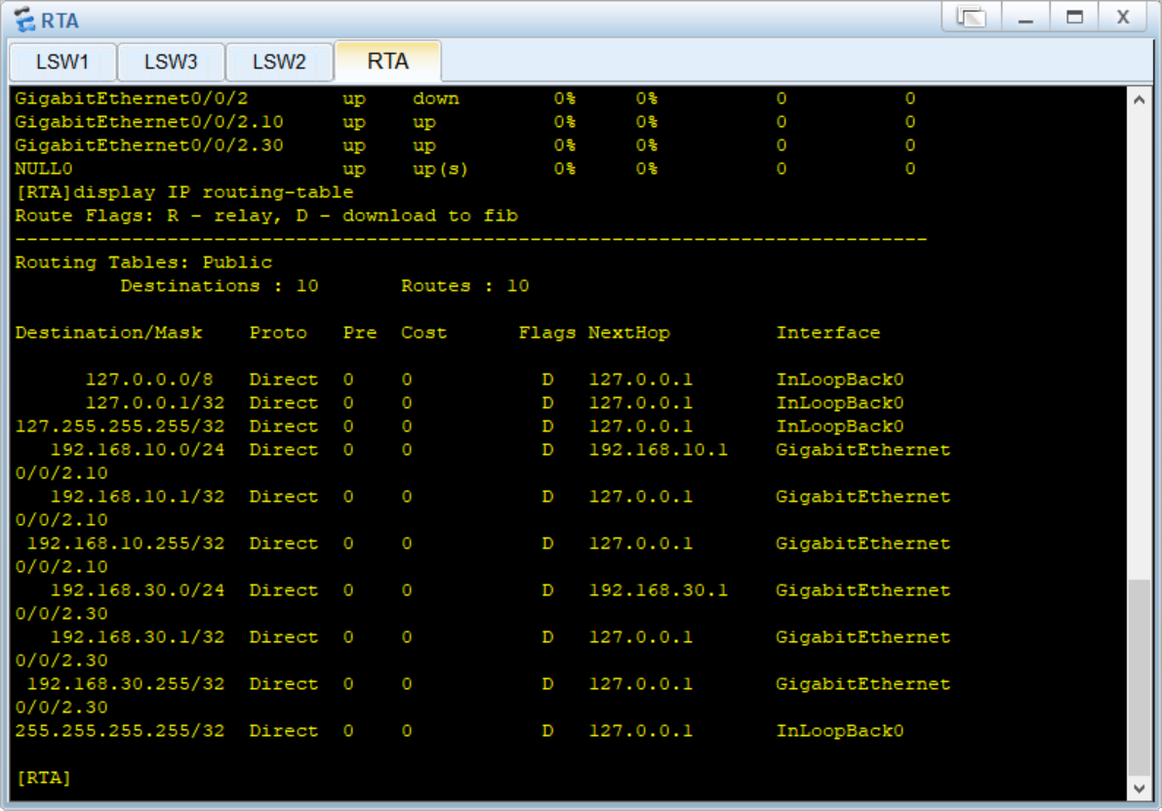

Q3-2.3. Can PC-10-1 and PC-10-3 ping each other? Please paste the screenshot of the ping result.
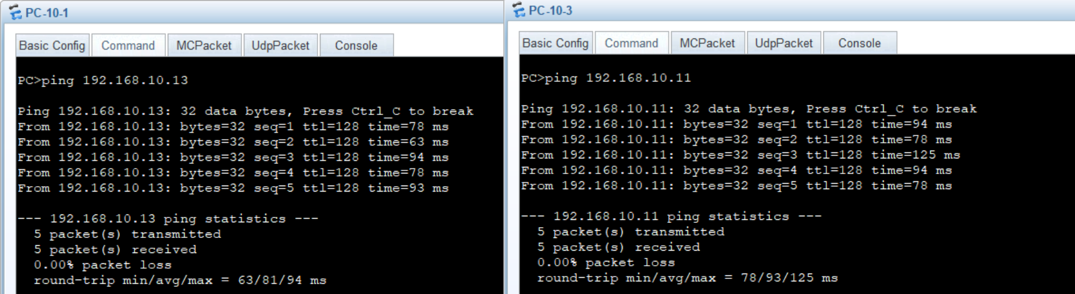

Q3-2.4. Paste the screenshot of the result of command “tracert 192.168.30.13” issued from PC-10-1.
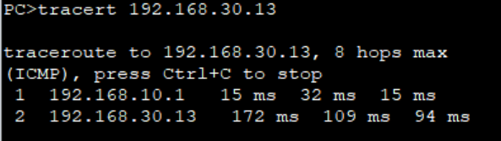

Q3-2.5. Analyze the captured ping traffics between the PC-10-1 and PC-10-3. What are the tagged VLAN IDs of the Ethernet frames leaving and entering the interface GE 0/0/2 on switch LSW3 ? Please paste the screenshot of the all field information of the captured Ethernet frame.
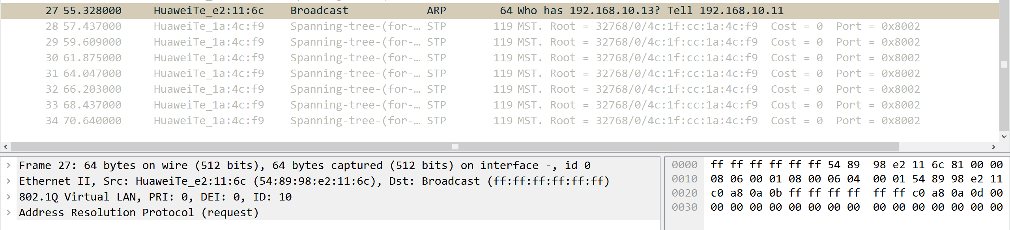

Q3-2.6. Analyze the captured ping traffics between the PC-10-1 and PC-10-3. What are the tagged VLAN IDs of the Ethernet frames leaving and entering the interface GE 0/0/24 on switch LSW3 ? Please paste the screenshot of the all field information of the captured Ethernet frame.
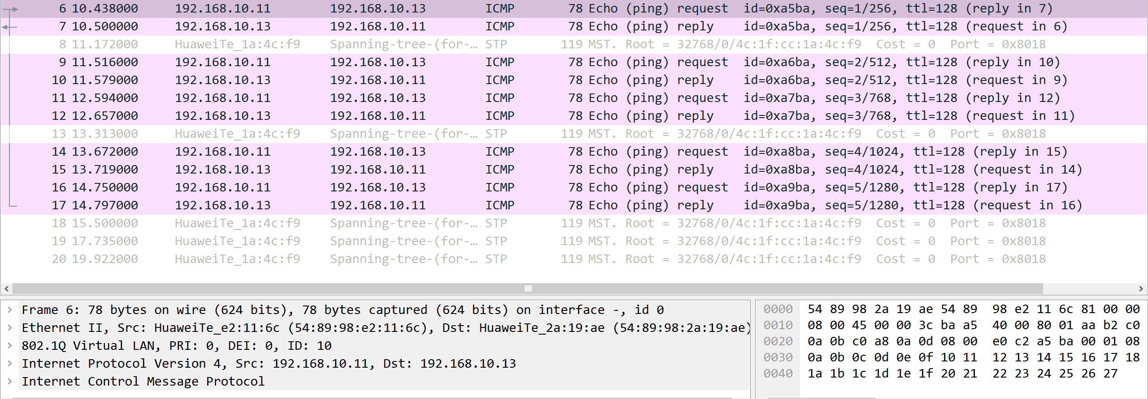

Q3-2.7. Analyze the captured ping traffics between the PC-10-1 and PC-10-3. What are the tagged VLAN IDs of the Ethernet frames leaving and entering the interface GE 0/0/2 on router RTA? Please paste the screenshot of the all field information of the captured Ethernet frame.
